SOFTWARE REQUIREMENTS SPECIFICATION

FOR

Biometric ATM Banking System

Group members:

1. SHIVANSH MISHRA
2. LAKSHMI RANGA SAI
3. SARANGLAL T
4. SIDDHARTH GHOSH
5. PRAKHAR CHITRANSH

Table of Contents:

1. **Purpose and Scope Purpose**

1.1.1 System Requirements Specifications Purpose

1.1.2 System Requirements Specifications Intended Audience

* 1. **Scope** 
     1. Products for Production
     2. Inclusions
     3. Exclusions
     4. Application Benefits, Objectives and Goals
  2. **Definitions, Acronyms, and Abbreviations** 
     1. Definitions
     2. Acronyms
  3. **Overview**

1. **Requirements Elicitation and Gathering Elicitation Methods**
   * 1. Brainstorming
     2. Surveys and Questionnaires
     3. Joint Application Development
   1. **Stakeholders** 
      1. Stakeholders and Roles

**Table 2.2.1 Stakeholders and Roles**

* 1. **Elicitation Technique Summary** 
     1. Brainstorming **Figure 2.3.1 Brainstorming**
     2. Surveys **Figure 2.3.1 Survey Elicitation**
  2. **Elicited Document Summary** 
     1. Functional Requirements
     2. Non-Functional Requirements

**Figure 2.4.1 Elicitation Summary Documentation Diagram**

# 3 Requirements Analysis and Methodology

**3.1** **Analysis Methods**

**3.2** **Analysis with UML Use-Case Model Figure**

**3.2.1 Use-Case Diagram**

3.2.1 UML Use-Case Descriptions

**3.3** **Analysis with State Transition Method**

**Figure 3.3.1 ATM Initialization State Transition Model**

**Figure 3.3.2 Transaction State Transition Model**

**3.4** **Analysis with Sequence Diagram Model**

**Figure 3.4.1 Session Use Case Sequence Diagram**

**Figure 3.4.2 Session Use Case Sequence Diagram**

**Table 3.4.1 Flow of Events**

**3.5** **Analysis Summary**

3.5.1 Use Case Model

3.5.2 State Transition Model

3.5.3 Sequence Model

# 4 Requirements and Software Quality Measurements

**4.1** **Software Quality**

**4.2** **Required Software Quality Attributes**

4.2.1 Functionality

4.2.2 Reliability

4.2.3 Usability

4.2.4 Standards Compliancy

4.2.5 Interoperability

**4.3** **Quality Metrics**

4.3.1 Product (Functional) Quality

4.3.2 Process (Structural) Quality

4.3.3 Project Quality

**4.4** **Software Quality Metrics**

4.4.1 Functionality and Reliability Metric

4.4.2 Usability Metric

4.4.3 Standards Compliancy Metric

4.4.4 Interoperability Metric

**Figure 4.4.1 Software Quality Weighted Attribute Metrics**

**4.5** **Quality of End Product**

**Figure 4.5.1 The Priority-Severity Matrix.**

1. **Requirements Validation and Verification 5.1** **Requirements Management** 
   1. **Validation**
   2. **Verification**
2. **Requirements Specifications**

**6.1** **Introduction**

* + 1. Purpose
    2. Scope
    3. Overview
  1. **Overall description** 
     1. Profile Database
  2. **Specific requirements** 
     1. ATM Terminal Interface
  3. **Functions of Biometric Logon**
  4. **Analysis Method 6.6** **Performance requirements**
  5. **Logical database requirements: N/A or to be added later**
  6. **Design constraints: N/A or to be added later**
  7. **Software Quality Attributes**

**6.10** **Requirements Management**

* + 1. Validation
    2. Verification

**6.11** **Supporting Documents**

# 7 Appendix

**7.1** **Terms**

|  |  |
| --- | --- |
| **1** | **Purpose and Scope** |

## 1.1 Purpose

1.1.1 System Requirements Specifications Purpose

The purpose of this document is to detail the requirements for a “Biometric ATM Banking System” software. This formal document will be used to define the stakeholders’ problem and solutions to solve the problem.

1.1.2 System Requirements Specifications Intended Audience

This document is intended for the developers, engineers, managers, the customer and all other stakeholders in the system.

## 1.2 Scope

1.2.1 Products for Production

The products to be developed include the Biometric ATM Banking System and a Biometric Database.

1.2.2 Inclusions

The Biometric ATM Banking System will allow customers to logon to their bank accounts using biometrics and a pin. Customers will sign up at any Lock Bank location. Their biometric profile of their unique features and characteristics will be stored in a database for comparison during account access requests. Approved access will give the customer limited banking functions. The software will allow biometric logon using a mobile application if it is compatible.

1.2.3 Exclusions

Excluded from this project are the required hardware, mobile application development and device compatibility outside of the Lock Bank equipment. While the application does allow for mobile application access, the development of the mobile application is third party and support for the mobile application is not included. Mobile applications and privately owned equipment functions are introduced but not within this scope. All details pertaining to mobile applications, mobile devices and privately own equipment are included solely for future considerations and expansion of this project. Functions that the software will not allow includes: access to tax documents or the ability to download activity.

1.2.4 Application Benefits, Objectives and Goals

Lock Bank recognizes that there are several risk factors associated with plastic ATM card use for banking. Carrying an ATM card has risks that are a result of: card fraud, card duplication, card sharing by family and friends, inability to trace use by unauthorized users, PIN copying, loss and theft. The benefit of using a Biometric ATM is that it is safer and secure. There is no need to carry a card that could be lost, stolen or skimmed.

Lock Bank’s goal for the Biometric ATM Banking System is to provide convenience and security for their banking customers that sign up. With this new system, Lock Bank will provide greater services than their competition in order to stay competitive. Account access monitoring accuracy will be increased since biometric authentication is based on a customer’s unique characteristics.

## 1.3 Definitions, Acronyms, and Abbreviations

1.3.1 Definitions

|  |  |
| --- | --- |
| **Biometrics** | The quantifiable data or metrics based on human characteristics or traits. |
| **Biometric**  **Identification** | A form of identification and access control using biometrics and a computer device. |
| **Fingerprint verification** | Customer finger matching to the unique marks of their fingerprint. |
| **Voice verification** | Customer speaks a word or phrase into biometric device for speech matching |
| **Ocular scanning** | Analyzes the unique patterns and features of the eye. |
| **Facial recognition** | Analyzes the overall facial structure, including measurements of distances between eyes, nose, mouth, and jaw edges. |
| **Customer** | An account holder with Lock Bank |
| **Stakeholder** | Any individual with a vested interested in the Biometric ATM Banking System |

### *1.3.1.1 Table 1.3.1 – Definitions*

(Sandhu & Betab, 2014, p. 184).

1.3.2 Acronyms

|  |  |
| --- | --- |
| **ATM** | Automated Teller Machine |
| **PIN** | Personal Identification Number |
| **POS** | Point of Sale |
| **AB** | Account Balance |
| **AN** | Account Number |
| **EFT** | Electronic Funds Transfer |

*1.3.2.1 Table 1.3.2 – Acronyms*

(American Bank, n.d.).

## 1.4 Overview

This document is broken down into six sections and a reference list. This section provides and overview of the project. Definitions, acronyms, stakeholders, application goals and benefits, purpose and scope are identified.

Section two explains what elicitation is and different elicitation methods. Different types of stakeholders, their role and interaction with the system and their importance is also covered.

Section three provides an overview of the system functionality and system interaction with other systems and identified during elicitation. Different analysis methods are discussed and an analysis methodology is implemented for stakeholder understanding and review.

Section four covers application requirements and quality requirements intended for developers and designers. Required quality measures are provided.

Section five is used to ensure that the system meets the defined requirements. This is done using verification and validation. A traceability matrix is used for this process.

The fourth chapter deals with the prioritization of the requirements. It includes a motivation for the chosen prioritization methods and discusses why other alternatives were not chosen. The Appendixes in the end of the document include the all results of the requirement prioritization and a release plan based on them.

|  |  |
| --- | --- |
| **2** | **Requirements Elicitation and Gathering** |

## 2.1 Elicitation Methods

Requirements elicitation is a complex process of obtaining a complete understanding of stakeholder’s requirements. The process involves seeking, determining, learning, acquiring, discovering and elaborating requirements of potential stakeholders. There are two main factors that affect obtaining quality requirements: method used and people involved. A project involves different stakeholders in various fields. Focusing on the project requirements is best done with the correct stakeholders are included (Yousuf & M.Asger, 2015). There are also several techniques or methods for elicitation. Some well-known techniques include: Brainstorming,

Group or Individual Interviewing, Document Analysis, Focus Groups, Interface Analysis,

Observation Social Analysis, Prototyping, Joint Application Development (JAD) or Requirements Workshops, Use cases and scenarios (UCD) or Process Modeling, Questionnaires and Surveys (Khan, 2015).

There is not one elicitation method that is ideal for all projects. There are several factors that must be considered when choosing the best elicitation technique. Some of these factors are available resources, project type, individual preference and business procedures to name a few. Elicitation techniques can be classified as traditional, contextual, collaborative or cognitive. Traditional techniques, like Questionnaires/Surveys, Interviews and Document Analysis are the most commonly used methods. Contextual techniques are obtained in the environment in which they will later be implemented like Observation methods. Cognitive techniques involve an in-depth understanding of the problem and are interdisciplinary. These include Card Sorting, Laddering and Repertory Grids (Yousuf & M.Asger, 2015).

Collaborations techniques will provide elicitation requirements for the Lock Bank Biometric ATM Banking System project. Collaborative Techniques involve teams or groups of stakeholders where each individual’s experience is used to come to a collaboratively agreed upon decision. The methods in this technique category include: Prototyping, Joint Application

Development (JAD), Brainstorming, Requirements Workshops, Group Work and Process Modeling. The Biometric ATM Banking System will employ the Brainstorming and Joint Application Development methods (Yousuf & M.Asger, 2015).

2.1.1 Brainstorming

Brainstorming is an informal process where numerous ideas can be produced from a group of people in a relatively short amount of time. There is very little cost or resources required (Khan, 2015). All ideas are recorded and those that are not appropriate or are impractical are omitted. Collaboration is easy to implement and it allows all stakeholders the ability to speak freely and equally.

2.1.2 Surveys and Questionnaires

Surveys and questionnaires foster efficient information elicitation from many stakeholders. The success of these techniques is highly dependent on the audience chosen. These techniques can be used independently or in combinations of each other. For the Biometric ATM Banking System elicitation both methods were used in together. First the stakeholders were presented with the purpose and the goal of the system. Each was asked to consider their own experience using an ATM for banking processes. Then they were prompted to provide details about ATM banking positives and negatives based on their own experience. The survey identified caution areas to consider during development. The survey also provided the stakeholders with information for introspection.

Following the survey, stakeholders were presented with a questionnaire. The questionnaire provided ideas and design considerations that were suggested during the brainstorming elicitation. The questionnaire was very specific, well defined and provide domain information.

2.1.3 Joint Application Development

The Joint Application Development (JAD) method involves a 4 or 5-day organized collaboration workshop that produces a proper set of user requirements. Key participants are specifically selected and participant roles and system goals are predefined. The use of visual aids fosters interactive sessions and an end of session prototype accelerates the design of a system. JAD sessions lead to creative output and greater user satisfaction. Participants remain in session until a complete set of requirements is developed, documented and agreed upon. The biggest benefit of JAD sessions is the increased communication between stakeholders, analysist and other professionals involved in the development process. Pitfalls of the JAD method include the need for a trained facilitator and the extensive amount of planning and effort required. If preplanning is not done sufficiently or properly, this method could lead to a great waste of time and resources (Yousuf & M.Asger, 2015).

## 2.2 Stakeholders

A stakeholder is any entity that has a vested or declared interest in the success or failure of a system or software being developed. Stakeholder Analysis (SA) during a software or system elicitation process since a stakeholder has a “stake” in the end product. SA is a method that accounts for and often incorporates the needs of the stakeholders. Understanding the stakeholders’ role, interests and weight that their input carries will facilitate realistic and sustainable development.

During system elicitation, selected stakeholders are needed to provide divergent viewpoints, shed light on the impact, identify opposing opinions, and address any potential issues with the expected solution being developed. Stakeholders range in form, size and capacity and can be individuals, organizations or unorganized groups.

2.2.1 Stakeholders and Roles

The new Lock Bank Biometric ATM Banking System has both internal and external stakeholders that should be considered during elicitation. In the following Table 2.2.1 Stakeholders and Roles, key stakeholders are identified and their roles are defined.

# Table 2.2.1 Stakeholders and Roles

|  |  |
| --- | --- |
| Lock Bank Biometric ATM Banking System Stakeholders | |
| Acquirers | Develop a plan and oversee procurement of the system that will meet the goals of and address the problem presented by Lock Bank. |
| Assessors | Ensure that the system conforms to the needs, standards and legal regulations. |
| Bank managers | Oversee the bank personnel and are responsible for ensuring they adhere to policies and job role duties. Also responsible for issue resolution at branch location. |
| Communicators | Contributors that communicate with, document and provide training to stakeholders germane to the system. |
| Competition | Representatives of other banks |
| Counter staff | Bank tellers that assist or account specialists that assist with various banking needs. |
| Customer | Sometimes referred to as the client, the customer pays for the development. The customer often includes "C" level management (e.g. CEO, CFO, CIO) and can hinder development usability over costs. |
| Database administrators | Develop, configure, identify and resolve issues of all features and capabilities of the database system. |
| Developers | Use system specifications to develop or lead a team in the development of the system. |
| Maintainers | Responsible for managing the system as it evolves once operational. |
| Production Engineers | Design, deploy, and manage the hardware and software the system will be built, tested, and run on. |
| Security managers | Oversees security of the system by leading a security that monitors the system use and network traffic. Security teams watch and respond to security system alerts. |
| Suppliers | Provide necessary components for which the system will run (e.g.  hardware, software, infrastructure, etc.). |
| Supporters | Helps the user with the system once it is in place and operational. |
| System administrators | Keep the system operational, administer users, and perform system configuration. |
| Testers | Test the system to verify it is ready for use. |
| User | Users can be divided into two types: content providers and content consumers. Content providers (e.g. bank personnel) input information into the system. Content consumers (e.g. bank account holders) use the system to access and consume system resources. |

## 2.3 Elicitation Technique Summary

The greatest challenge is including the correct stakeholders for input. Including the wrong stakeholders only yields a long document of input that has to be omitted because it is irrelevant or not feasible. With the correct stakeholder there is a quality of information elicitation.

The Joint Application Development (JAD) would have be developed based on ideas elicited from the brainstorming, survey and questionnaire techniques. Due to time constraints and inability to gathers stakeholders in one location for a multiday session, it was not feasible.

2.3.1 Suggestions for Improvement

Brainstorming negatives of this method is that it can be very time consuming if not properly organized, idea quantity do not equal idea quality and it is easy for extroverts to monopolize the session with their ideas (Yousuf & M.Asger, 2015).

Group Work or Focus Group techniques are an alternative to the brainstorming technique. As with brainstorming, stakeholders are gathered to share, suggest, discuss and consider suggestions from all attendees. Participants are encouraged to interactively engage with each other to generate new ideas and discuss as many topics possible in depth. A group work session is more formal than brainstorming and requires a moderator to keep the group focused and maintain order. Generating thoughts freely is encouraged but there is a risk of disproportionality if the moderator is unable balance participation resulting in a group influenced by dominant participants.

2.3.2 Elicitation Summary Documentation

The combination of the elicitation techniques provided features and functions that the stakeholders felt were important. Some will still need to be addressed and considered for feasibility and necessity. Documentation is essential for successful development. Figure 2.4.1 Elicitation Summary Documentation Diagram provides a summary diagram of the compiled results. For a larger detailed double click on the inserted Diagram 2.4.1 Visio Elicitation Summary below.

This documentation will be further analyzed in Section 3.

## 2.4 Elicited Document Summary

2.4.1 Functional Requirements

* User Setup: In order to use the biometric system, the user will have to create a biometric profile. Profile must be created at a bank location with a bank agent during normal business hours. The profile will be stored on a dedicated biometric database server.

* Welcome Screen User Interface: The welcome screen will prompt the user to choose either a Biometric Profile or ATM card account identification.

* Biometric Profile Selection: If user selects biometric profile they will be prompted with a list of options including fingerprint, iris, voice or facial recognition.

* Fingerprint Selection: User will be prompted to place their finger on the scanner until the system has recognized their finger print.

* Iris Selection: User will be prompted to stand with their eye approximately three inches from the camera and remain until the system recognizes their scan.

* Facial Selection: User will be prompted to stand in front of the camera approximately one foot from the machine for facial scanning until recognized.

* ATM card selection: User will be prompted to enter their ATM card and then remove.

* Successful Identification: The system will welcome the user by name that matches the record on file and prompt to confirm it is their account.

* PIN: After user confirms that the correct account has been found the system will prompt for a second form of identification, a PIN.

* Successful Logon Options: Upon successful logon user will be prompted to choose a transaction. The options are balance inquiry, balance transfer, withdraw cash and deposit.

* Failed attempt logon: System will allow user three logon attempts. After the third failed attempt the system will take a photo of the user to send to a forensics team, lock the users account, notify account holder and bank of failed logon attempts. A message will display notifying the user that the account has been locked and provide a number to contact for support.

2.4.2 Non-Functional Requirements

Locations: Biometric ATMs will be located on bank property only. They will be inside the bank, attached to the outside of the bank or in a bank drive through lane.

Attributes: Security, Convenience and Increased service.

**Figure 2.4.1 Elicitation Summary Documentation Diagram**

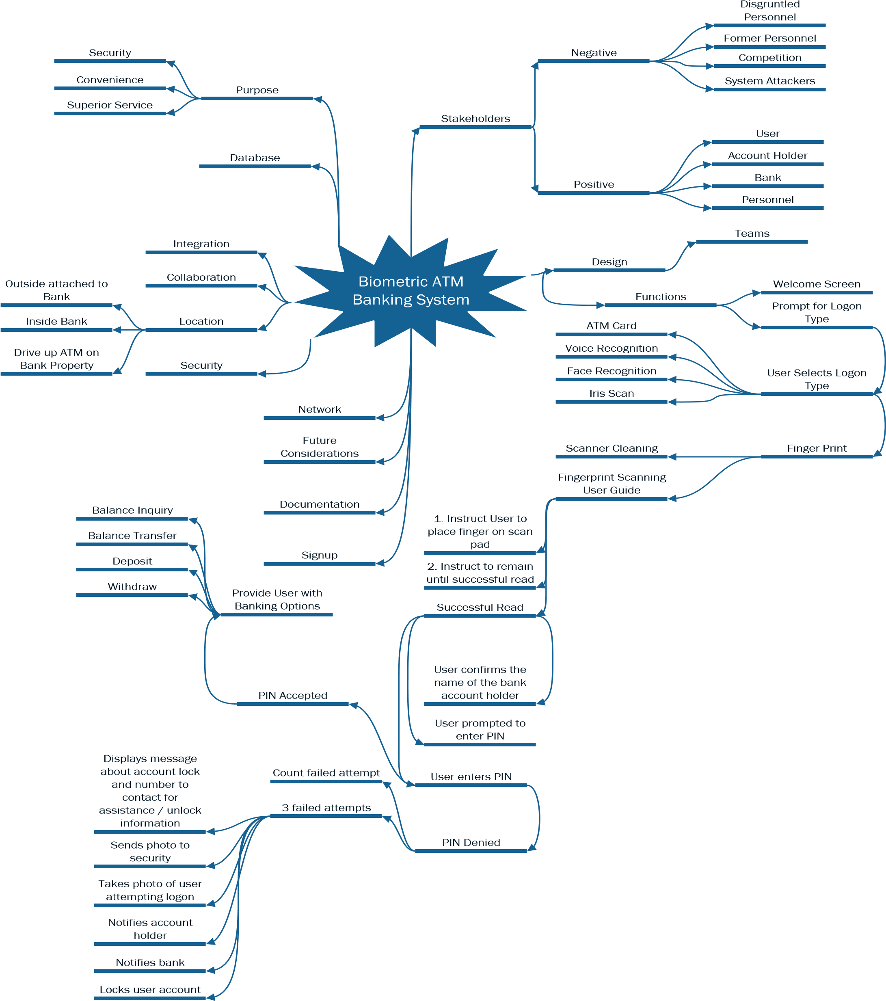

|  |  |
| --- | --- |
| **3** | **Requirements Analysis and Methodology** |

## 3.1 Analysis Methods

Analyzing requirements is the process of identifying what is needed in order to fulfill a need or solve a problem. It includes understanding the problem domain and solutions that can address the problem. During requirements analysis, design teams review requirements to determine if they are actionable, measurable, testable, relative to domain needs, and sufficient in detail for system design.

Computer-aided software engineering (CASE) tools are important for systems analysts. These tools provide the Unified Modeling Language (UML) and the different diagrams used to break down the UML. Some features of a system are fixed. This means that there are elements that do not change and are a part of the structures system. The structure model gives a general design of the system as a whole. To visually represent the different behaviors and define the rationale behind the tasks or responses of the system, UML uses different diagrams in order to break down the structure and behaviors (Tutorials Point, n.d.).

There are several modeling diagrams that can be used to assist systems analyst the opportunity to break down the functionality of the system. This can make the system easier to organize and identify complexities to simplify for greater understanding. Some of the structure model types are the class, component, object and deployment diagrams (Tutorials Point, n.d.).

Behavioral modeling of UML, diagrams the interactions in a system. A behavioral model represents the generalized dynamic nature of a system. The activity, timing, sequence, use case, state machine, and communication diagrams show the constraints and assumptions of the system and the system’s users.

This section will explain three selected types of behavioral modeling: use case, sequence, and state machine. A diagram of each is included to represent specific functions of the system. A flow of events and use case definitions provide an in depth analysis of the biometric ATM system.

## 3.2 Analysis with UML Use-Case Model

A use case is a description of actions or events that take place between an actor and a system to solve a problem or meet a goal. Use-cases in UML can be visually represented using use case diagrams. A use case diagram can graphically depict actors, use cases, associations, dependencies and the system boundary (Strohmeier & Sendall, 2001).

There are three relationships in a use case diagram: extends, includes and generalization. The ‘includes’ relationship indicates that the behavior of a child use case is part of the parent use case behavior. The ‘extends’ relationship indicates that the behavior of a child use case is part of another use case that is at a specified location. A ‘generalization’ relationship is between a general parent and a more specific child entity (Strohmeier & Sendall, 2001).

A use case model includes a use case diagram and descriptions. The Use Case diagram gives an overview of individual use cases and how they pertain to the system as a whole. The actors for the biometric ATM bank system include the account holder (user), agent, database, ATM, operator and technician. See Figure 3.2.1 Use-Case Diagram.

# Figure 3.2.1 Use-Case Diagram

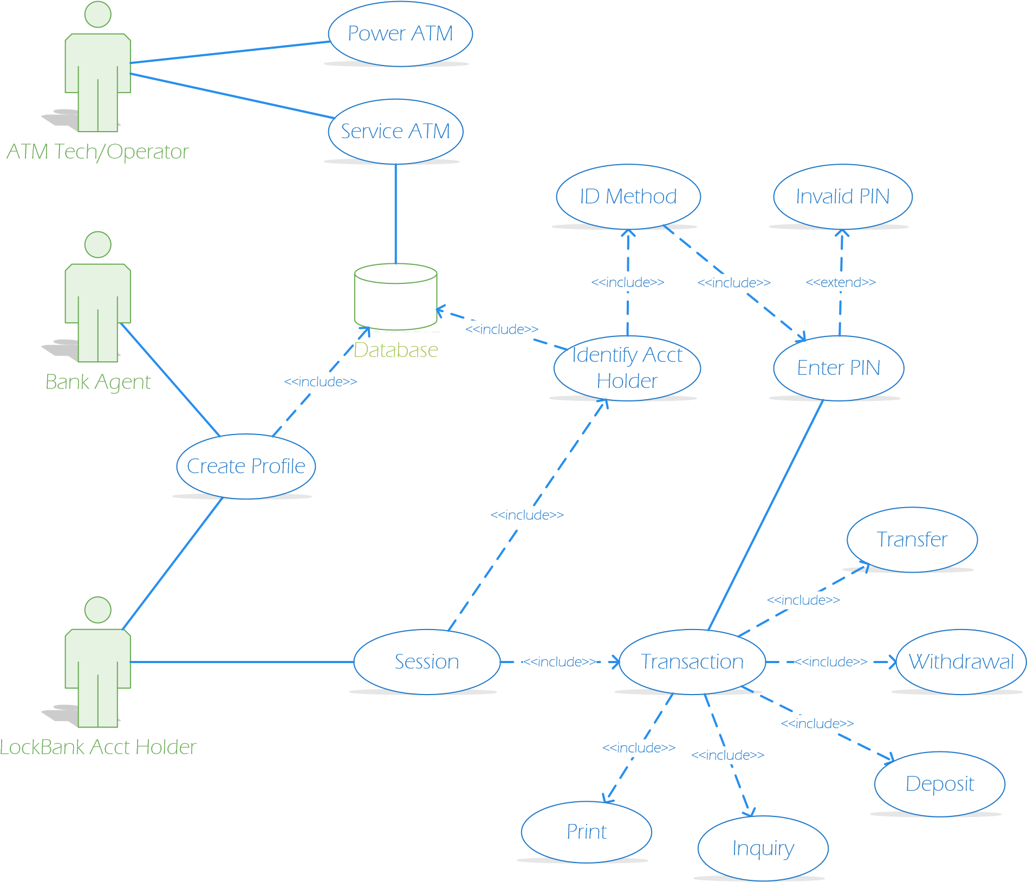

3.2.1 UML Use-Case Descriptions

The biometric ATM bank system assumes that all users of the system have a valid Lock

Bank account. To create a biometric profile, it is also assumed that the user has visited the Lock Bank location during normal business hours. There are three main actors in the usecase model: Teller, Account holder and ATM Tech/Operator. A final assumption is that the software is installed on both the teller’s computer for sign up and the ATM.

## *3.2.1.1 Create Profile*

Biometric profile setup requires two actors: a bank agent and an account holder (user). An agent will assist user in creating the biometric profile using the biometric equipment. The user will choose one or both (facial/finger) biometric(s) profile to create. For a facial profile the agent will scan the user’s facial features and send the record to the database. For a finger print, the user will place their finger on a scanner while the agent accepts a clean scan. The agent then sends the scan to the database. The agent will then walk the user through a test logon using their newly created biometric profile. Problems with access may require rescanning or else an ATM Tech will be requested to resolve the issue.

## *3.2.1.2 Power ATM Use Case*

The system is powered up when the ATM Operator flips the switch to the "on" position. The ATM connects to the networked database. The ATM is then at the Welcome screen and available for use. When the ATM needs to be serviced the ATM Operator begins the shutdown procedure after he verifies it is not in use. Then the operator flips the switch to the "off" position. The network connection to the database is closed.

## *3.2.1.3 Service ATM Use Case*

The ATM Operator is responsible for replenishing paper and cash, removing all deposits, etc. The ATM Operator must check the card reader to make sure there is nothing the slot. If the ATM needs additional servicing it must be shut down first.

## *3.2.1.4 Session Use Case*

A session is started when a user chooses an ID logon method. If the user selects biometrics they will select the type of biometric to use. A finger print selection will prompt the user to place their finger on the scanner until a scan is accepted. A facial selection will prompt the user to stand in front of the camera about a one foot back until the camera scan is accepted. If either scan is unsuccessful the user will be prompted again. After three failed scan attempts the session will end and the ATM will return to the welcome screen. If the user selects ATM card, then he is prompted to insert the card into the card reader slot. The ATM accepts and reads the card. Unsuccessful read will eject card and end session. The ATM will return to the Welcome screen. After the user has completed a biometric scan or inserted an ATM card, the database will identify the user and request that he enter a PIN. Successful verification of PIN will prompt user for a transaction selection. Failure to verify the PIN will initial the Invalid PIN extension. Session ends when the user selects not further transactions requested.

## *3.2.1.5 Transaction Use Case*

A transaction use case prompts the user to select a transaction type from a menu of possible transactions. Transactions include withdrawal, inquiry, deposit, and transfer. The flow of transactions can be seen in the State Chart Diagrams. Transactions can be cancelled when the user presses the Cancel key as described in each individual type of transaction below.

## *3.2.1.6 Withdrawal Use Case*

A withdrawal prompts the user to select account to withdraw from and a dollar amount from a menu of possible amounts or by entering an amount in intervals of $20 up to a max of $300. The system verifies account has sufficient funds. If insufficient funds, user is informed and prompted retry another amount. If funds are available, withdrawal is approved, the amount is dispensed, the amount is posted to the account, and a receipt is printed. The transfer can be cancelled when the user presses the Cancel key prior to entering a dollar amount.

## *3.2.1.7 Deposit Use Case*

A deposit prompts the user to choose account to deposit to from a menu and enter a dollar amount on the keypad. The user is prompted to insert deposit envelope, the machine accepts from the user, and then prints a receipt. The deposit is posted as pending until funds are verified. The transfer can be cancelled when the user presses the Cancel key prior to inserting the envelope containing the deposit.

## *3.2.1.8 Transfer Use Case*

A transfer prompts the use to choose the to/from accounts for the transfer. Then the user is prompted to enter a dollar amount on the keypad. Once the bank processes the transfer, the ATM prints the receipt. The transfer can be cancelled when the user presses the Cancel key prior to entering a dollar amount.

## *3.2.1.9 Inquiry Use Case*

An inquiry prompts the user to select from a menu the account that the user is requesting balance information about. Once the bank returns the balance the ATM prints the receipt. The inquiry can be cancelled when the user presses the Cancel key prior to account selection.

## *3.2.1.10 Invalid PIN Extension*

An invalid PIN extension is started from within a session when the entered PIN is not match the database profile. The customer is prompted to re-enter the PIN and an authorization request is sent to the database again. If approved, the original use case transaction is continued; otherwise the user prompt to re-enter PIN is repeated. A successful PIN entry is used for the current and subsequent transactions in the session. A user failure to enter correct PIN three times cancels transaction, locks account, account holder and bank are notified, camera takes user photo, and ATM returns photo for forensics. ATM returns to Welcome screen.

## 3.3 Analysis with State Transition Method

The biometric ATM banking system is made up of states and behaviors. A state is the current condition of the ATM. The behavior is the transition trigged by an internal or external event between the states. State chart diagrams include an initial and a final state or the start and end events. The system is broken into two objects: Initialization and Transaction State Transition Models. These two objects have more complex behaviors that are easier to follow in a state transition diagram. See Figure 3.3.1 ATM Initialization State Transition Model and Figure 3.3.2 Transaction State Transition Model.

# Figure 3.3.1 ATM Initialization State Transition Model

Start

Wait for Account

Holder

Transaction Loop

End Transaction

End

Operator Confirms

Successful Powerup

Verify ID/Card

Selection

Select ID/Card ID

Verify PIN

PIN Accepted

Fail

Fail 3 times

Powerup ATM

Power off ATM

Operator Confirms Shutdown

Input

PIN

Fail <3 times

# Figure 3.3.2 Transaction State Transition Model

Start

Display Transaction

Menu

Withdrawal Dialog

End Transaction

End

Eject Card

Deposit Dialog

Select Deposit

Select

Inquiry

Check Balance

Select Withdrawal

Transfer Dialog

Select Balance Transfer

Select Account

Select Amount

Display Balance

Print Receipt

Deposit Successful

Post to Account

Insufficient

Funds

Input Deposit Amount

Another

Transaction?

Transaction

Complete

No More Transactions

Available Funds

Deny Request

Cancel/Try Again

Transaction

Approved

-

Dispense/Transfer

Funds

Take Cash

Confirm Transfer

Open Deposit Bin

Deposit Envelope Inserted

## 3.4 Analysis with Sequence Diagram Model

Sequence or flow of events analysis focuses on the events between the actors and the system. A sequence diagram depicts the process of message passing that takes place in order to perform one or more use cases. The models show the behavior of the system in response to inputs from other objects or actors and the order or timeline of those events. (Davies, n.d.).

Two use cases are depicted by a sequence diagram in this section: Session and transaction. See Figure 3.4.1 Session Use Case Sequence Diagram and Figure 3.4.2 Session Use Case Sequence Diagram. The session sequence diagram provides an overall sequence of the ATM user experience. It includes a transaction loop that is broken down in a more specific sequence diagram. From these sequence diagrams a flow of events has been compiled. See Table 3.4.1 Flow of Events.

# Figure 3.4.1 Session Use Case Sequence Diagram

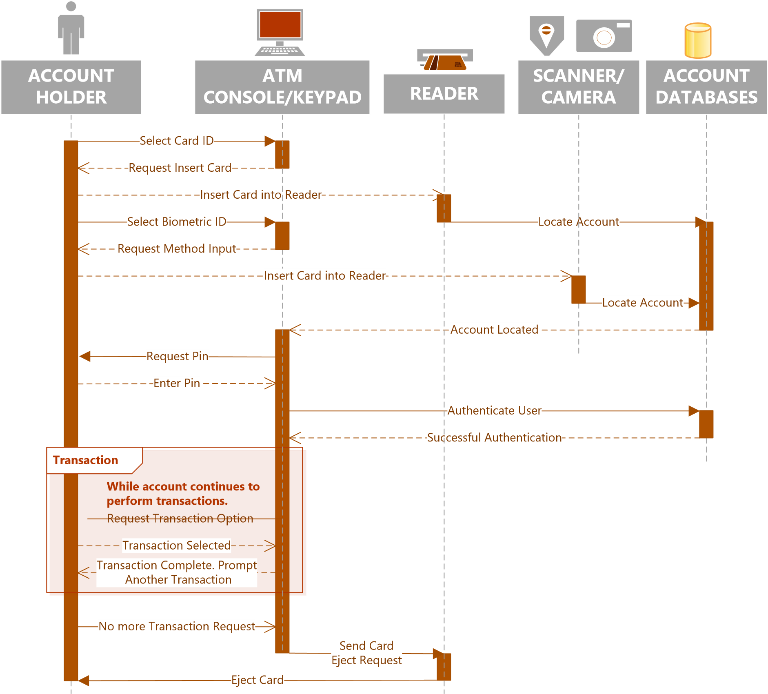

# Figure 3.4.2 Session Use Case Sequence Diagram

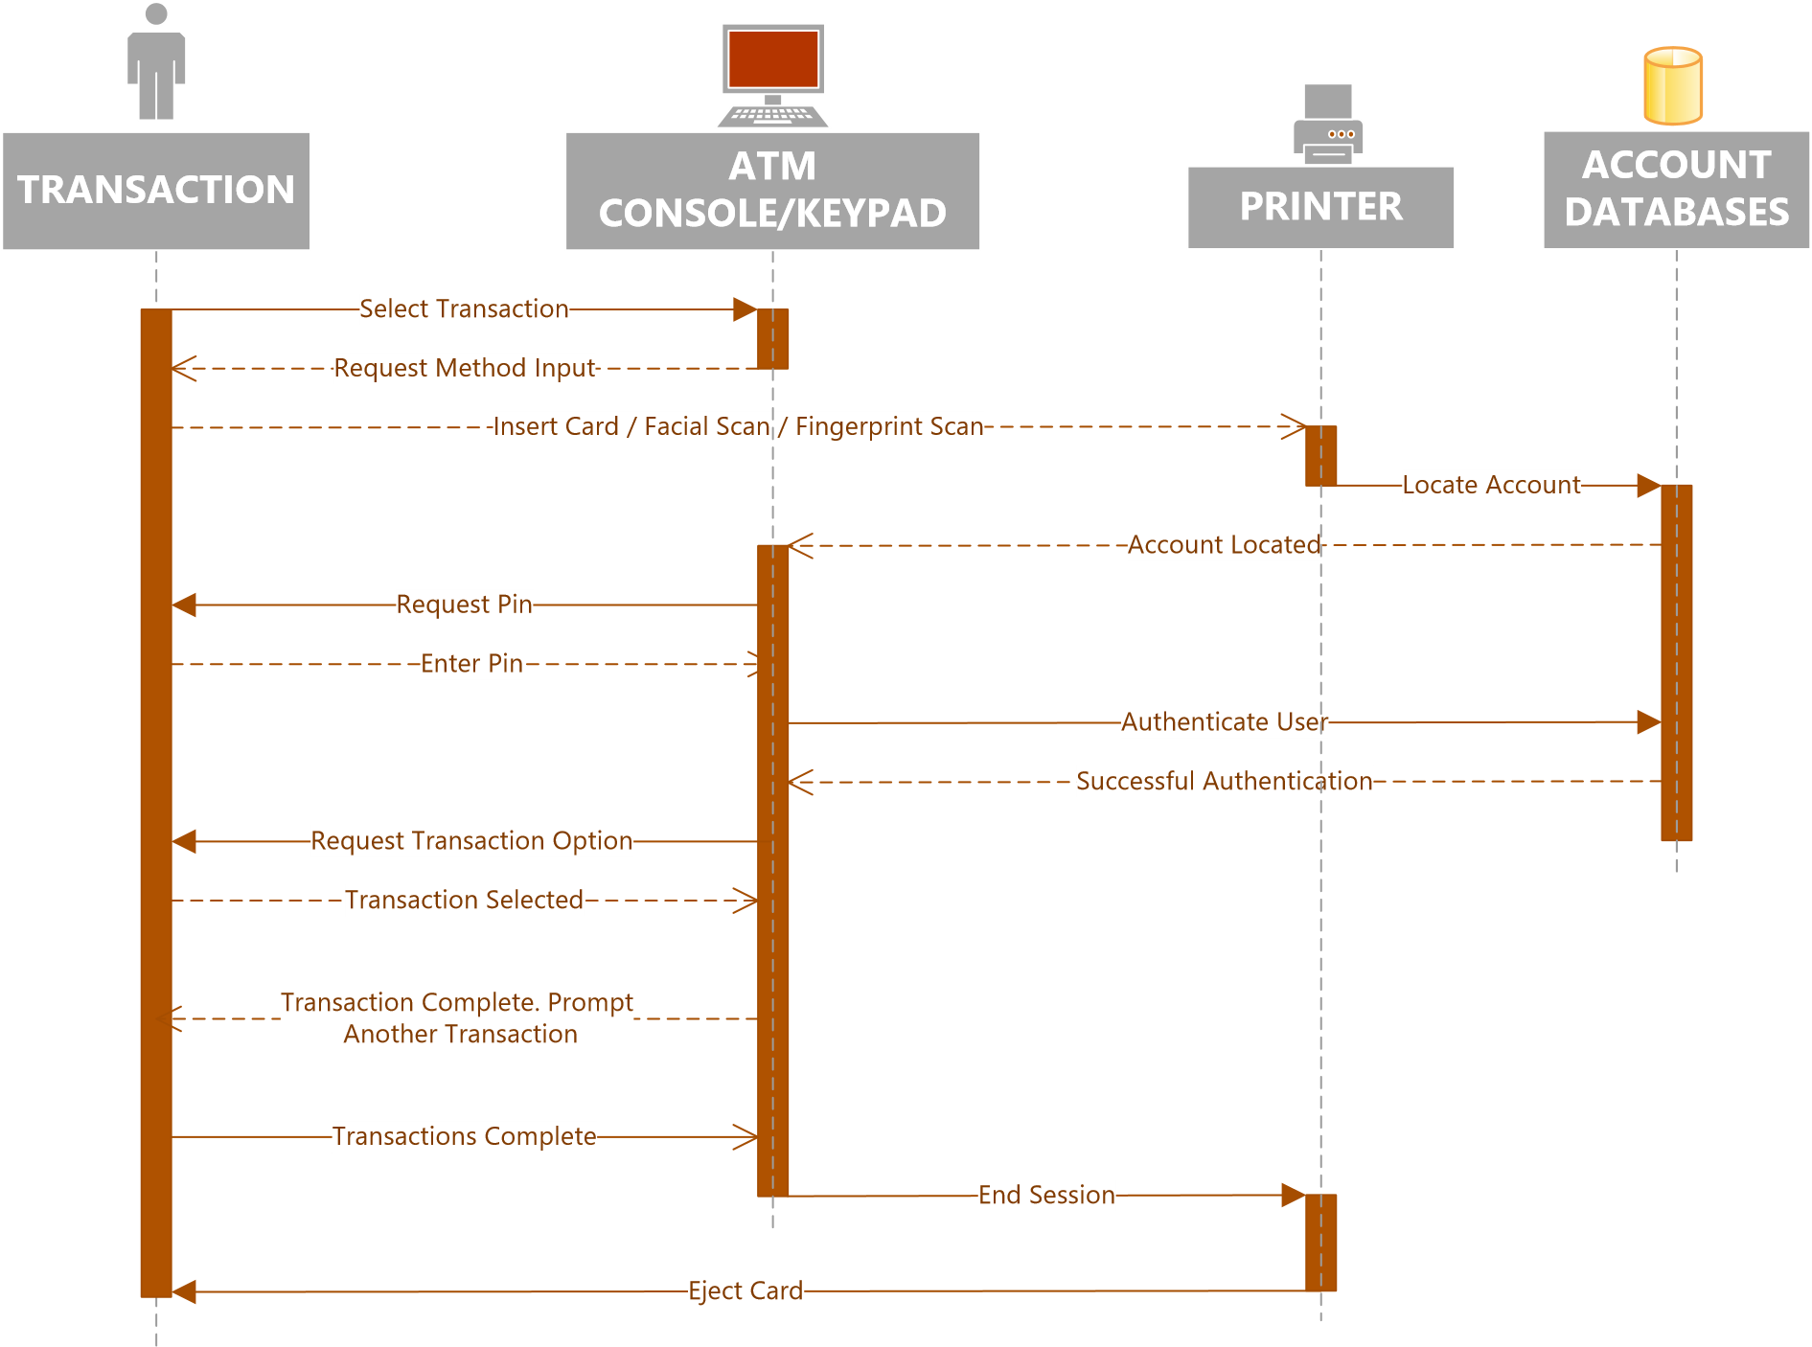

# Table 3.4.1 Flow of Events

|  |  |
| --- | --- |
| Actors | Agent, Account Holder, Operator, Technician |
| Preconditions | 1. Account holder met with agent to create profile 2. ATM is Powered on. 3. ATM is connected to networked database 4. Card reader is empty 5. ATM has paper 6. ATM has money 7. User has a Lock Bank Account |

|  |  |
| --- | --- |
| Flow of Events | 1. ATM operation begins at Welcome Screen 2. User chooses ID Method 3. If user choose ATM card, then he inserts ATM card into reader 4. If user chooses Biometric ID, then he chooses biometric choice    1. User selects fingerprint, ATM requests user to place his registered finger on the fingerprint reader    2. User selects facial recognition, ATM requests user to stand 1 foot from camera for a facial scan. 5. ATM requests user to enter PIN 6. If ATM has 3 failed authentication attempts, then ATM:    1. Takes photo of user    2. Notifies the account holder    3. Notifies the bank    4. Locks the account    5. Ejects the card 7. ATM requests user to make an operation selection choice 8. If user selects ‘balance inquiry’, then ATM    1. Sends request to database to retrieve current balance    2. Returns account balance to display and prints 9. If user selects ‘deposit’, then ATM    1. Prompts user to enter deposit amount    2. Accepts amount and prompts the user to insert deposit    3. Accepts deposit and posts pending deposit to account. 10. If user selects ‘withdrawal’, then ATM     1. Ask user for amount in increments of $20 and maximum of $300     2. Accepts amount and sends verification of funds request to database     3. If sufficient funds, then ATM dispenses requested amount and posts to account     4. If insufficient funds, then ATM notifies user to try again. 11. If user selects ‘transfer’, then ATM     1. Ask user for whole dollar amount.     2. Accepts amount and sends verification of funds request to database     3. If sufficient funds, then ATM transfers requested amount and posts to account     4. If insufficient funds, then ATM notifies user to try again. 12. ATM prompts user for another transaction.     1. If user chooses another transaction, then ATM     2. If user chooses no, then ATM prints receipt of activity 13. ATM ejects ATM card 14. ATM returns to Welcome screen |
| Post  Conditions | 1. Operator Powers down the ATM 2. Deposits are removed and given to Agent 3. Deposits are verified and posted to account 4. Operator checks paper and refills if needed 5. Operator checks cash available in machine. |

## 3.5 Analysis Summary

In this section, three behavioral analysis methods were used: use case, state transition and sequence. Each have their own benefits and challenges. This section will discuss the benefits and challenges of each.

3.5.1 Use Case Model

The Use Case method provides a very high level diagram overview that makes it simple to understand the key elements and behaviors of the system. The Use Case definitions add value to the model by providing details of all processes included in each use case. The definitions also provide boundaries to the system by providing alternatives. The challenge in this method is the level of detail that is needed to extract quality requirements. Each Use Case consists of many interactions and each must be considered carefully which is not depicted in the visual diagram. The other challenge is knowing when and how to use the relationships.

3.5.2 State Transition Model

The state transition model gives a graphical representation of the use cases with the inputs and outputs that occur between. This method provided the most insight for the requirements. The simplicity of the design makes it easy to see the use cases and the interactions between them. State transition models can be broken down in to smaller state transition models to make it easier to follow. The only challenge of this model was the fail loop or extension in the use case model. Since it loops back to itself it does not seem clear what is taking place.

3.5.3 Sequence Model

The sequence model is a great representation of the events order. It provides a depiction all actors, system, input and output. A well designed sequence diagram is very beneficial in understanding the processes and needed steps for the system goals. The diagram is very easy to follow and this makes flow of event definition easy. The challenges of this method is that the dependencies must be known and it is not a useful tool if dependencies are left out.

|  |  |
| --- | --- |
| **4** | **Requirements and Software Quality Measurements** |

## 4.1 Software Quality

Software quality in a project determines the success or failure of a system. Poor quality requirements and poor specifications documents are key contributors to project failure. Software quality is the foundation of the development process. Detection of poor quality requirements later in the development process result in costly redesign and rework (Chappell, 2012).

Dependence on software is present in all aspects of life therefore quality is imperative in all software projects for success. Specifications for software quality focus on software attributes and quality metrics (Elam, 2016).

## 4.2 Required Software Quality Attributes

Quality attributes are used to evaluate the performance of a software including behaviour, design and user experience. These non-functional requirements also known as “ilities”. There are many types of software quality attributes and vary in importance based on the software product.

To determine which “ilities” are important and required there are several factors to consider. Key considerations include goal of the project, business goals and future development. Industry standards compliance also drives required quality attributes. For a financial institution there are many compliance regulations including Gramm-Leach-Bliley Act (GLBA) and the Electric Funds Transfer Act (EFTA) ("Federal Regulations for Financial Institutions | CSI," n.d.).

The key required software quality attributes identified for the biometric ATM banking system include: functionality, reliability, usability, standards compliancy and interoperability. The software quality attributes are not all inclusive, rather focus on the key requirements for the Lock Bank biometric ATM software.

4.2.1 Functionality

The functionality of the software is the essential purpose of the biometric ATM banking system. Unlike other quality characteristics, functionality is either present or not present. The other quality characteristics are present to a certain degree.

4.2.2 Reliability

Once the ATM software is live and functional the system must be capable of maintaining service under defined conditions and time periods. An important reliability feature is fault tolerance or the ability to function in the event of component failure. A reliable software is available and recoverable.

4.2.3 Usability

Usability is a factor of functionality and addresses the ease of use of the software. Option menus and system help features aid in account holder understanding and use. A system that cannot be learned is not useful or usable.

4.2.4 Standards Compliancy

### *4.2.4.1 Security*

Software security protects the software from accidental or malicious access, use, modification or destruction. Security also refers to who has access or the access level that is granted to bank personnel. The security of a bank customer’s collected personal financial and confidential information is protected by enforcement of GLBA compliance.

### *4.2.4.2 Inspectability*

EFTA, also known as Regulation E compliance, focuses on investigative procedures of consumer claims and electronic fund transfer errors. The industry standards for the ATM software will require security and inspectability.

## 4.3 Quality Metrics

Software development has a specific approach for quality measurements since it is the process of building the software rather than purchasing an already existing system. The three key aspects of software quality include: product, process and project quality (Chappell, 2012).

4.3.1 Product (Functional) Quality The functional quality of software ensures that they software performs it’s intended tasks. Functional requirements include the goals of the stakeholders, following compliance and regulatory guidelines, quality performance, reliability, and usability. During elicitation, it is not uncommon to gather requirements that are not necessary. These features should be identified and addressed. The software should meet the requirements and not what a user wants to see from the software. Software that has defects, fails during operation or is difficult to use provides no benefit. The software must also work with existing systems (Boult, n.d.).

4.3.2 Process (Structural) Quality

The structural quality of software ensures that structure of the code is well developed. Quality software has code that is testable, maintainable and understandable. Software requirements or software needs often change over the life of software development. This means that the code must be easily maintainable or editable without introducing errors. Even following the development of a software, it must be maintained. The original developer of the system may not be the one that edits, maintains or modifies the code. If the code is not understandable, this can present unnecessary costs and time delays. Code security should also be considered as part of structural quality requirements. Poor coding can leave a system vulnerable to attacks. For the ATM banking system this is a risk that could be very costly (Boult, n.d.).

4.3.3 Project Quality

The development process quality impact users, the development team and sponsors. Timely delivery and meeting budget constraints are examples of process quality factors. Stakeholders are given a timeline on which they expect delivery and delays can cause frustration. For the ATM system, the bank has notified its customers of the system release. Delays will reflect poorly on Lock Banks ability to fulfill promised services. Customers anticipating services will be disappointed as well as question the banks’ ability to deliver. Delays can also cause development teams stress which can frustrate members causing them to quit. Exceeding allocated funds can cause delays, create a need for trade-offs that can impact quality, or result in the need to cut features decreasing the value of the system (Boult, n.d.).

## 4.4 Software Quality Metrics

This section identifies some important software qualities subdivided by their primary attribute. Following these identified key functions, they will be measured by weight of importance. This will provide insight to the features that are most important. See Figure 4.4.1 Software Quality Weighted Attribute Metrics. This quantitative software quality analysis is useful when determining areas that have room for tradeoffs and which cannot. Other metrics measure for criticality, time constraints and budget constraint impacts. This metric is used to show the attributes of the software and the weight of each attribute to the overall function.

4.4.1 Functionality and Reliability Metric

* User ID option input shall be verified as existing and qualified against database.
* Software must be able to perform transactions in an acceptable amount of time.
* Software must be able to sustain in any condition by identifying peak transaction times and days/dates for load and performance testing.
* Software shall measure metrics in terms of execute time and calendar by calculating the probability of failure free software operations.
* Software must have a failure rate percentage less than 2%.
* Software shall distinguish between software errors, faults and failures.
* Software will calculate Meantime between failure (MTBF) by adding the meantime to failure (MTTF) and meantime to repair (MTTR)
* Software must only allow authorized persons account access.
* Upon completion of processing transfers or withdrawals, software will post transaction to user account.
* Software shall be available for 99.9% of operating time.
* Software must have an acceptable user performance success rate.
* Software must verify available funds for transfers/withdrawals before approval and processing.

4.4.2 Usability Metric

* Software must be easy to learn and use for existing and new account holders.
* Software must display options on monitor for customer interaction. Software must accept user identification option.

4.4.3 Standards Compliancy Metric

* Historical activity logs must be accessible and comprehensible for authorized investigators by software verification and authentication.
* Software shall consistently return correct account data and accurately posts activity.
* All accepted or actionable transactions must be logged by software. • Software will monitor for suspicious activity.

4.4.4 Interoperability Metric

* The software shall operate with the existing database.
* Software shall connect and communicate over existing network.
* Hardware must adequately support the software and all its functions.

## 4.5 Quality of End Product

A software defect is an error, flaw, failure or fault in a software application that result an unexpected or unintended outcome. The purpose of software testing is to prove that a defect exists, not that a defect does not exist. Software defect testing is performed by Software QA testers. Identified defects are logged with attributes in a Defects Report. Criticality of effective defect tracking and resolution is most commonly measured by two key attributes: severity and priority. Defect Severity assigns a degree of negative impact to the quality of software. The higher the negative impact of a defect to business or software functionality the higher the severity. Defect Priority is used to determine the order in which a defect should be handled.

Assignment of priority is based on the cost and time to fix. A higher priority defect must be addressed and resolved sooner ("Defect Priority, Defect Severity and their Differences | Better Software Testing," n.d.).

There are four types of metric combinations that are used by development teams to determine the handling of software defects: High Priority & High Severity, High Priority & Low Severity, High Severity & Low Priority, and Low Priority & Low Severity. High priority & low severity combination indicates the need for an immediate fix but the defect does not affect the software functional requirements. High severity & low priority combination indicates that the defect has a high impact on the expected software functions but the negative impact is not immediate. High priority & high severity combination indicates that the defect has a major negative impact on software functions and it needs to resolved immediately. Low priority & low severity combination indicates that the software functionality is not impacted but there is a small degree that does not meet specifications.

|  |  |
| --- | --- |
| **5** | **Requirements Validation and Verification** |

## 5.1 Requirements Management

Requirements are gathered and expanded on throughout the SDLC. Prior to management, requirements have been elicited, analyzed, elaborated, negotiated, specified and validated to meet the customer’s need. Requirements are also verified to determine if they are necessary, complete, consistent, unambiguous, attainable and verifiable. The next stage is to manage the requirements.

Before the software requirements document can be handed over to a development or design team, requirements must be organized and managed. There are standards on which requirements management are based including: IEEE Standard 1233, IEEE Standard 830 and SEI CMMI. The requirements management process includes identifying, controlling and tracking requirements as the project proceeds. Requirements can be organized and managed by verification and validation (Elam, 2016).

Validation and verification are the final processes that are used to ensure that both the processes of the software and the quality of requirements are met. These two processes are a review to make sure nothing is missed or overlooked. The key differences between verification and validation reviews are the focus and participants during review processes.

## 5.2 Validation

Validation is a process that proves software does what it is intended to do. This takes place throughout the SDLC. This type of process is also known as iterative or an agile environment. Validation first begins prior to prototyping where no design has been formulated. The requirements are defined with the stakeholders to ensure they meet the customer needs. Validation focuses on process requirements. The validation review is done with stakeholders to make sure that the software meets the needs of the end user (Elam, 2016).

The validation review process begins with the requirements description and is validated against how the customer explained it. This process began at the elicitation stage. By correctly validating requirements as explained by the customer, a complete picture of the customers’ needs is obtained.

## 5.3 Verification

Verification makes sure that the requirements are necessary, complete, unambiguous, consistent, attainable and verifiable. The focus of verification is to review the documented requirements quality. Quality of writing means that requirements are provided in compliance with standards. Implementation or design details are not given during verification. The verification process is necessary to prevent revisiting the customer for requirements. The customer provides input at a very high level. This is not sufficient for implementation and design (Elam, 2016).

|  |  |
| --- | --- |
| **6** | **Requirements Specifications** |

### 6.1 Introduction

6.1.1 Purpose

The purpose of this document is to detail the requirements for a “Biometric ATM

Banking System” software. This formal document will be used to define the stakeholders’ problem and solutions to solve the problem.

6.1.2 Scope

*6.1.2.1 ATM software will allow customers to logon using biometrics or ATM card and a pin.*

*6.1.2.2 Customers will sign up at any Lock Bank location.*

*6.1.2.3 Biometric profile will be saved on a bank database for verification on ATM use.*

*6.1.2.4 Specifications exclude the hardware, mobile application development and device compatibility outside of the Lock Bank equipment.*

6.1.3 Overview

The SRS includes definitions, acronyms, stakeholders, application goals and benefits, purpose and scope are identified.

### 6.2 Overall description

* The Biometric ATM Banking System will allow customers of Lock Bank with a valid account to create a biometric profile. Customers create a biometric profile with one or both offered features: facial recognition and fingerprint.
* The user will need to setup a biometric profile. There are several guidelines to meet for profile creation.
* User must sign up at a bank location
* Sign up is done with the assistance of a bank agent. This means that it must be done during normal business hours.
* New bank account holders will be offered the biometric feature at time of account setup.

6.2.1 Profile Database A user’s profile will be stored in a database for account access verification. A database will need to be developed that will accessed for verification upon user input. Considerations for the database are as follows.

* The biometric profiles will be stored on an independent Database Server
* The operating system will be a Linux based system for added security • Failsafe backup database server

### 6.3 Specific requirements

6.3.1 ATM Terminal Interface

The Terminal window will follow steps to guide the user. The first screen the user will see is the Welcome screen which will ask how the user wants to log on: Biometrics or ATM Card.

### 6.4 Functions of Biometric Logon

* Customer can inquire about their account balance
* Funds can be transferred between Lock Bank accounts • Deposits can be made into any qualified account. • Customer can withdraw cash.

### 6.5 Analysis Method

* Create Profile
* Initialize ATM Use Case
* Shutdown Use Case
* Session Use Case
* Transaction Use Case
* Withdrawal Use Case
* Deposit Use Case
* Transfer Use Case
* Inquiry Use Case
* Invalid PIN Extension

### 6.6 Performance requirements

• Session Initialization • Power up ATM

* Verify ID/Card Selection
* Wait for Account holder
* Verify PIN
* Transaction Loop
* End Transaction
* Power off ATM

### 6.7 Logical database requirements: N/A or To be added later

**6.8 Design constraints: N/A or To be added later**

**6.9 Software Quality Attributes**

6.9.1 Functionality

* the system shall provide four banking options: transfer, deposit, withdrawal, and inquiry.
* the system will be able to identify a Lock Bank user using ATM card or biometric options.
* The software shall accept and read a cash card
* The software will communicate with the bank computer to carry out the transaction
* Software shall dispense cash and print receipts
* the system post transactions and update a user’s account

6.9.2 Usability

* the system will have an easy to follow user interface.
* the system shall provide a help option to guide ATM users.
* Use tools to test with a user interface.
* the system shall provide instructions for the selected biometric method when in use.

6.9.3 Reliability

* the software will mirror the database for fault tolerance in the event of drive failure.

6.9.4 Interoperability

* Software runs on Windows Operating system.
* Software can communicate with SQL database.
* Hardware, software and other components support software.

6.9.5 Standards Compliancy: Security and Insatiability

* the system shall prevent SQL injection.
* Develop an investigative digital forensics plan
* Perform static code analysis to examine code for security issues.

### 6.10 Requirements Management

6.10.1 Validation

Stakeholders include Lock Bank personnel and Tech Rep, Inc. This iterative review resulted in an agreed upon list of customer requirements based on their needs as below. • Create Profile

* Session
* Transaction
* Withdrawal
* Transfer
* Deposit
* Inquiry
* PIN Error
* Power ATM
* Service ATM

6.10.2 Verification

Prior to releasing this document to the design and development teams it has been reviewed to check the quality of requirements specifications. Tech Rep has met with the development and design teams to go over the requirements specification to ensure all requirements are clearly defined before development begins.

### 6.11 Supporting Documents

* Use Case Diagram
* State Transition Model
* Sequence Diagram
* Flow of Events Table
* Software Quality Weighted Attribute Metric
* Traceability Matrix

|  |  |
| --- | --- |
| **7** | **Appendix** |

### 7.1 Terms

**Metric**: A quantitative measurement of an attribute of a system, software or process. **Measure**: An indication of the size, quantity or amount of a quality attribute of a system, software or process.

**Failure**: The result of a fault.

**Fault**: An incorrect step, process or data definition in a software application.

**Error**: The difference between a computed result and the expected result

**MTTF**: Meantime to failure

**MTTR**: Meantime to repair

**MTBF**: Meantime between failure is equal to the MTTF and MTTR.

**Operating Time**: Period in which a system is working with an acceptable level to the operator.

**Mistake**: An action by a user that produces an incorrect result.

|  |  |
| --- | --- |
| **8** | **References** |

American Bank. (n.d.). Bank acronyms. Retrieved from https://www.ambnk.com/custom/fi/ambnk/fb/disclosure/BANK-ACRONYMS.pdf

Boult, T. E. (n.d.). *Software Requirements Specification (SRS) Template*. Retrieved from University of Colorado Colorado Springs website:

www.uccs.edu/Documents/tboult/srs.doc

### Chappell, D. (2012, March 16). *The three aspects of software quality: Functional, structural, and process* [PDF]. Retrieved from

http://www.davidchappell.com/writing/white_papers/The_Three_Aspects_of_Software_ Quality_v1.0-Chappell.pdf

Colabello, James S. (1988). *Introduction to software verification and validation*. Pittsburgh, PA: Carnegie Mellon University, Software Engineering Institute.

Davies, P. J. (n.d.). *Requirements analysis and use-case diagrams* [PPT]. Retrieved from https://web.cs.dal.ca/~hawkey/3130/UseCaseDiagrams.ppt

Defect Priority, Defect Severity and their Differences | Better Software Testing. (n.d.). Retrieved from http://bettersoftwaretesting.blogspot.com/2009/12/defect-prioritydefect-severity-and.html

Elam, D. (2016, December 5). *CS641 161205 - Unit 4* [Adobe Live Chat]. Retrieved from http://ctuadobeconnect.careeredonline.com/p28guolmhzb/?session=breezo29nswu6dw c8sp7m